Model Deployment

Name: expense_prediction
Report date: 07/27/2022
Internship Batch: LISUM11: 30
Version: 1.0
Data intake by: Priyadarshani Kamble
Data intake reviewer: NA
Data storage location: https://bitbucket.org/pk_projects/work/src/week4/Income_Expense_Data.csv

Tabular data details:

Total number of observations | 14
Total number of files | 1
Total number of features | 3
Base format of the file | csv
Size of the data | 1KB

Note: Replicate same table with file name if you have more than one file.

Proposed Approach:

A: Create and Pickle a Machine Learning Model

I used Income_Expense dataset and created a model using LinearRegression model. This model will predict the expense of the person using income and age as input features.
Please refer to https://bitbucket.org/pk_projects/work/src/week4/expense_prediction.ipynb

This model performs below operations:
- Step 1 - Import data
  - Explore the data
- Step 2-Data Cleaning:
  - Looks for missing values, replaces missing data with appropriate values using imputation technique.
  - Checking Outlier by definition and treating outliers
- Step 3- Exploratory data analysis
  - Check how Expense is varying with income
  - Check how Expense is varying with Age
  - Check correlation matrix - to check the strength of variation between two variables
- Step 4-feature engineering
  - Normalization/scaling of data - understanding scaling
  - Converting data back to pandas dataframe
  - Separating features and response
  - Dividing data in test and train
  - Importing necessary packages
  - Fitting linear regression model
  - Checking accuracy on test data
  - Predict values on test data

This creates a model that can predict the expense of person with ~68% accuracy.

B Model Deployment prep:
Model can then be pickled using

import pickle
pickle.dump(model, open('expense_prediction.pkl','wb'))

The pickle file can be found inside the same directory as the Jupyter notebook.
https://bitbucket.org/pk_projects/work/src/week4/expense_prediction.pkl

C Write Flask App:

Using IDE or visual studio code, create a new .py file inside the working directory named app.py. which looks like the snapshot below.
The structure of the code follows:
- Load pickled model
- Name flask app
- Create a route that receives inputs through a html page, uses the trained model to make a prediction, and returns the prediction in a html format, which can be accessed through the API endpoint.
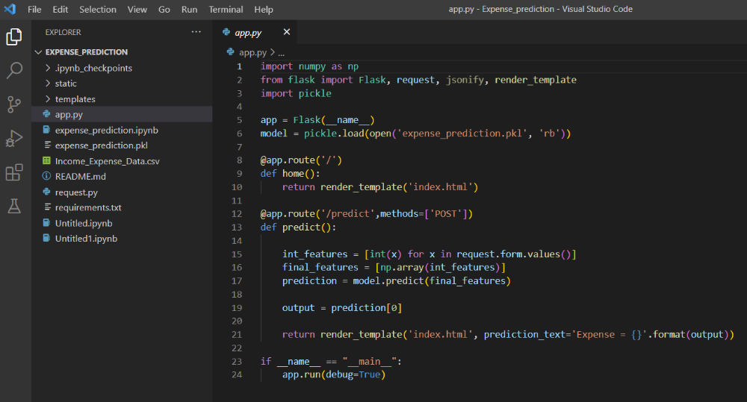

The app file uses render_template function to load index.html
Index.html is nothing but a user interface which accepts input variables for income and age and returns expense as output.
This template can be found in
https://bitbucket.org/pk_projects/work/src/week4/templates/index.html

app file further uses predict() function to predict the output.

D:

Once the app.py file is ready, I ran the flask app from the command line as below
python app.py

I got the following message with the address:
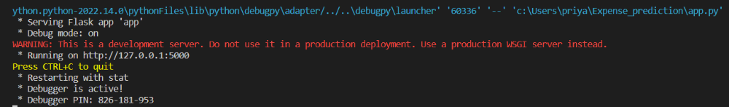

The app can now be tested using url http://127.0.0.1:5000

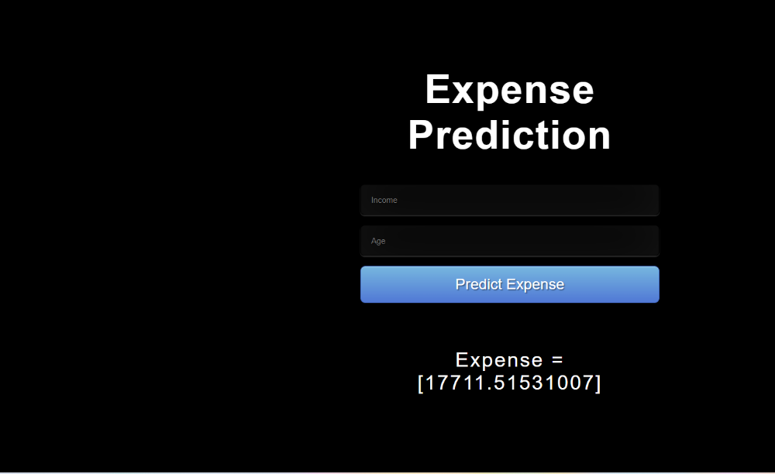

The model predicted 17711 as expense for input variables income =30000 and age = 24.

Step E : Create requirements.txt
The requirements.txt file contain all the dependencies for the flask app. This can be created using below command:
pip freeze > requirements.txt

The folder contains below files.
